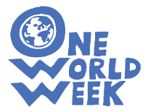

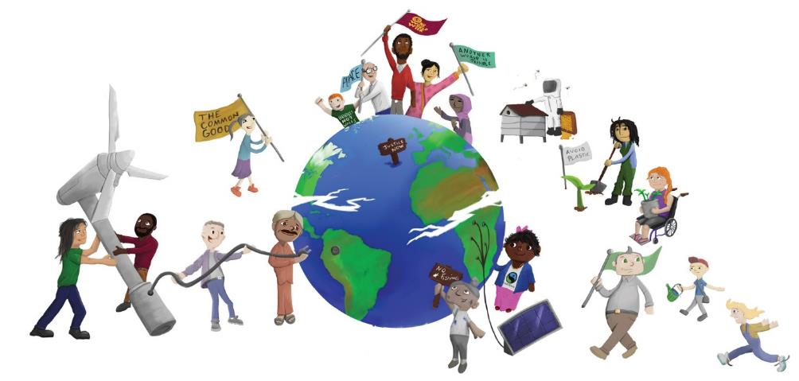
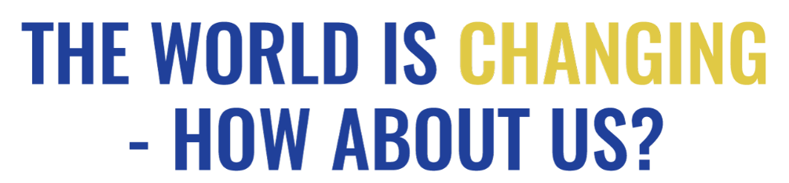
Illustration by www.webber-design.com
QUOTATIONS

How could you use these quotations?
- To stimulate thinking - you could select individual quotations, enlarge them and print them off – then put them in eye-catching positions around your event:
  - on tables if you are having a meal;
  - on seats for a presentation;
  - on the wall, if people are circulating;
  - include them in displays;
  - include appropriate ones in an interfaith event or worship;
  - give one to everyone as they come into the event. (Follow up by inviting them to sign up to a pledge later in the event or as they leave – see Pledges)
  - Make the concise ones into bookmarks, laminate them, let people choose in return for a donation.
- As part of your publicity – choose pithy arresting ones to catch the interest!
- As part of a discussion activity - give one to everyone or, if people are sitting round a table, let people choose one they like. Invite them to share it with the others and initiate a discussion about what changes need to be made to ensure a future for our children and what they, themselves might do. You could use this together with the Pledges.
- As part of an interfaith event – invite people of various faiths to share their faiths’ teaching about what needs to change and bring quotations. You can offer these, on page 7, as a starting point or to add to the faiths represented at your event.
- Your ideas – we would love you to share your ideas about how to use quotations with other OWW organisers. Contact us and we’ll put them on the website.
The quotations
We found the following quotations from various sources, as indicated, - from websites, publications and reports. You will probably know lots more.
Please tell us about your favourites – with sources if possible and we’ll include some of them on the website or use them to update this list.

WHY? - Changes in Planet Earth’s systems

“We are the first generation to know that we’re undermining the ability of the Earth system to support human development…. This is a profound new insight and it’s potentially very, very scary … This is also an enormous privilege because it means that we are the first generation to know that we now need to navigate a transformation to a globally sustainable future.”
Rockstrom, J. The Great Acceleration. Lecture 3, in Planetary Boundaries and Human Opportunities. 2014;
Quoted in Raworth, K. Doughnut Economics (2017) p55

“We pursue all the lodes in the earth, live above mined areas and then are amazed that sometimes the earth gapes open or begins to tremble ... The thought of the long-term effect of draining the earth’s resources and the full impact of greed is truly worrying.”
Elder Pliny (AD23-79)

“Our 21st century goal: “Human prosperity in a flourishing web of life”
Raworth K. (2017) Doughnut Economics p. 60

The conundrum we find ourselves facing:
We have an economy that needs to grow, whether or not it makes us thrive.
We need an economy that makes us thrive whether or not it grows.
Raworth K. (2017) Doughnut Economics p. 268

“The need to reduce demand for livestock products is now a scientifically mainstream view. Only a significant decrease in meat and milk consumption will allow us to deliver a food system fit for the future – for the benefit of humans and the planet as a whole.”
Pete Smith, Former Convening Lead Author for the
Intergovernmental Panel on Climate Change, March, 2018.

“Ours is the era of the planetary household - and the art of household management is needed more than ever for our common home”
Raworth K. (2017) Doughnut Economics p. 57

(There is a) “need to move away from industrial agriculture towards agro-ecological models. There is a groundswell – it’s almost starting to be a zeitgeist as key thinkers in civil society start to join the dots and see that actually we do need a new style of agriculture which goes beyond industrial agriculture, which goes beyond simple sustainability, which brings us to a point of regeneration.”
Dr. Hilal Elver, UN Special Rapporteur on Right to Food

‘“Mō tātou, ā, mō kā uri, ā muri ake nei – for us and for our children after us.” That is what’s at stake when we talk about climate change – the world we’ll leave for the generations that follow us. They are why we need to act now, with purpose and courage.’
Maori saying quoted by Jacinda Ardern, PM of New Zealand, Guardian 218.04.2018

“No generation has a freehold on this Earth. All we have is a life tenancy – with a full repairing lease.”
Margaret Thatcher 1988 in a speech to the Royal Society

“There’s enough on this planet for everyone’s needs but not for everyone’s greed”
Mahatma Gandhi

“The world is getting too small for both an Us and a Them. Us and Them have become co-dependent, intertwined, fixed to one another. We have no separate fates, but are bound together in one. And our fear of one another is the only thing capable of our undoing.”
Sam Killermann (comedian)

“Bad ideas flourish because they are in the interest of powerful groups”
Paul Krugman (economist)

HOW? - Can we change the world?

“If you think you are too small to make a difference, try living with a mosquito”
Dalai Lama XIV

“Never doubt that a small group of thoughtful, committed, citizens can change the world. Indeed, it is the only thing that ever has.”
Margaret Mead (Anthropologist)

“Activism is the rent I pay for living on this planet.”
Alice Walker

“Change will not come if we wait for some other person, or if we wait for some other time. We are the ones we've been waiting for. We are the change that we seek.”
Barack Obama

“The way to change the world is through individual responsibility and taking local action in your own community.”
Jeff Bridges (actor – see his video about plastic pollution here )

“They always say time changes things, but you actually have to change them yourself.”
Andy Warhol, The Philosophy of Andy Warhol

“Yesterday I was clever, so I wanted to change the world. Today I am wise, so I am changing myself.”
Jalal Ad-Din Rumi. Persian poet, mystic 13th Century.

“Education is the most powerful weapon which you can use to change the world.”
Nelson Mandela

“One child, one teacher, one book, one pen can change the world.”
Malala Yousafzai, (education activist and Nobel Peace Prize winner)

“If you want to change the world, pick up your pen and write.”
Martin Luther, (Protestant Reformer, 1483 -1546)

“You must be the change you want to see in the world.”
Mahatma Gandhi

“Everyone thinks of changing the world, but no one thinks of changing himself.”
Leo Tolstoy (Writer)

“Act as if what you do makes a difference. It does.”
William James (Philosopher and Psychologist)

“You may not be able to change the world, but at least you can embarrass the guilty.”
Jessica Mitford

“If I can't change the world, at least I want to change the way people look at it.”
Antoni Tapies (Artist 20th Century)

“I alone cannot change the world, but I can cast a stone across the waters to create many ripples.”
Mother Teresa

“Let him who would move the world first move himself.” Socrates (470-399 BC)

“How wonderful it is that nobody need wait a single moment before starting to improve the world.”
Anne Frank

“The world is changed by your example, not by your opinion.”
Paulo Coelho (Brazilian novelist)

“Buy less, choose well, make it last.”
Vivienne Westwood, (fashion designer and businesswoman)

“Those who contemplate the beauty of the earth find reserves of strength that will endure as long as life lasts.”
Rachel Carson

FAITH RELATED

‘Who can stop climate change? We can. We have a responsibility to do so that began when God commanded the earliest human inhabitants of the Garden of Eden to 'till it and keep it'. To keep it; not to abuse it, not to destroy it’
Desmond Tutu

“When love is the way, we will let justice roll down like a mighty stream and righteousness like an ever-flowing brook … poverty will become history ... the earth will be a sanctuary”
Bishop Michael Curry, Primate of the Episcopal Church, 19 May 2018

“The ultimate test of a moral society is the kind of world that it leaves to its children.”
Dietrich Bonhoeffer, (German pastor, theologian, anti-Nazi dissident)

“Oh, you who believe! Stand out firmly for justice, as witnesses to Allah, even as against yourselves, or your parents, or your kin, and whether it be (against) rich or poor…”
[Qur’an 4:135]

“We must learn to live together as brothers, or we are going to perish together as fools”
Martin Luther King, Jr.

[Prophet], “call [people] to the way of your lord with wisdom and good teaching. Argue with them in the most courteous way.”
Qur’an 16.125

The Prophet [peace be upon him] said “none of you truly believes until you love for others what you love for yourself.” [Bukhari]

“Whoever sees anything unjust, let him change it with his hands…” [Hadith].

“I believe that to meet the challenges of our times, human beings will have to develop a greater sense of universal responsibility. Each of us must learn to work not just for oneself, one's own family, or nation, but for the benefit of all humankind. Universal responsibility is the key to human survival. It is the best foundation for world peace”
Tenzin Gyatso, 14th Dalai Lama

“Let us pray that all living beings realise that they are all brothers and sisters, all nourished in the same life source.” Buddhist

